Mental Health Department
Data Folio and Dashboard
Name: Ismail Saleh

Datafolio:
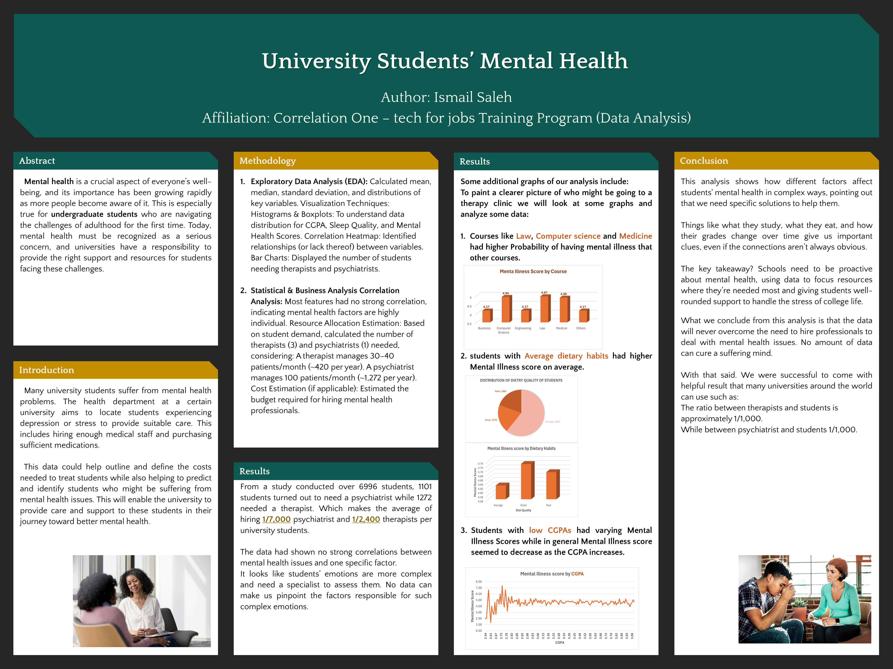

Dashboard:
https://public.tableau.com/views/UniversityStudentsMentalHealth_17396206597960/Dashboard1?:language=en-US&publish=yes&:sid=&:redirect=auth&:display_count=n&:origin=viz_share_link

